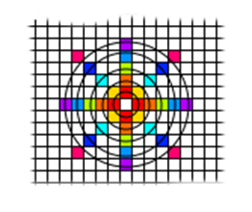***Earth governs fundamental structure,***

***Water dictates flows and cycles,***

***Air controls etheric effects,***

***Fire oversees the exchange of fundamental energies.***

|  |  |  |  |  |
| --- | --- | --- | --- | --- |
|  | *Earth* | *Water* | *Air* | *Fire* |
| 0 |  |  |  |  |
| 1 |  |  |  |  |
| 1+ |  |  |  |  |
| 2 |  |  |  |  |
| 2+ |  |  |  |  |
| 3 |  |  |  |  |
| 3+ |  |  |  |  |
| S |  |  |  |  |
| S+ |  |  |  |  |